**Campus Life**

**and Student Resources**



**Campus Life Student**

**and Student Resources**

**charlotte.edu/landing/campus-life**

The University of North Carolina at Charlotte provides a comfortable and enjoyable environment for students that is conducive to learning. The services, facilities, and programs of the University promote individual student development and foster a community which promotes the involvement of students in their intellectual, cultural, spiritual, emotional, and physical development.

Students at UNC Charlotte are encouraged to participate in extracurricular activities. Athletics, the Student Government Association, the Campus Activities Board, and Student Media are a few of the available activities that can play a significant role in each student's development and total education. Participation in activities, ranging in type from service and religious to athletic and social, and from creative arts and crafts to wilderness experiences, increases a student's opportunities to acquire leadership skills, to experience the responsibilities involved in functioning within a self-governmental process, and to develop personal talents and interests.

***Note:*** *Students are entitled to participate in several student groups and organizations as long as they are academically eligible to continue their enrollment. However, participation in some activities requires students to be in good standing with the University, both academically and in accordance with The Code of Student Responsibility (located in the “University Regulation of Student Conduct” section of the Catalog).*

**Enrollment Management**

**enrollment.charlotte.edu**

**Adult Students Admission Program (ASAP)**

Adult students, 24 years of age or older who have been out of school for five or more years and present appropriate educational credentials, are encouraged to make an application through the Office of Undergraduate Admissions. This unique program offers adults the opportunity for special admissions status, an academic advisor through the Office of Adult Students and Extended Services (OASES), and adult transitional support services throughout the first two years of their enrollment. Students who declare a major are advised through their major department.



**New Student Orientation (NSO)**

New Student Orientation (NSO) occurs during the summer and immediately prior to the Fall and Spring semesters.  Led by a team of dedicated staff and student leaders, NSO prepares students and families to succeed at UNC Charlotte by understanding academic expectations, developing connections with their peers, and learning about important campus processes. Learn more at orientation.charlotte.edu.

**Niner Guides**

Part of Undergraduate Admissions, Niner Guides are the University’s official tour guides. Being a Niner Guide is more than just giving tours, it is sharing your love of the University with prospective students and their families when they visit our beautiful campus. Program benefits include: volunteer experience, priority class registration for active guides who fulfill tour requirements, leadership and personal growth opportunities, and public speaking and communication skills. Learn more at admissions.charlotte.edu/connect/niner-guides.

**Office of Adult Students and Extended Services (OASES)**

OASES serves as a principal resource for nontraditional and adult students and is committed to supporting and enhancing educational experiences. Services include academic and career advising, an adult student transition course, educational and social programming, and extended morning and evening office hours. Programs include an adult student orientation, the Alpha Sigma Lambda Honor Society, scholarships, and the 49er Finish Program. Visit oases.charlotte.edu for detailed information and office hours.

**Athletics and Recreation**

**charlotte49ers.com**



**Charlotte 49ers/Athletics**

The Charlotte 49ersDepartment of Athletics provides competition in 18 intercollegiate varsity sports for men and women, with the addition of women’s lacrosse coming in 2024-25. Each sport competes under the governing powers of the National Collegiate Athletic Association (NCAA) at the Division I level, which is the highest competitive level for collegiate varsity sports. Scholarships are available for all varsity sports, male and female.

Male student-athletes compete in nine sports: baseball, basketball, cross-country, football, golf, soccer, tennis, indoor track and field, and outdoor track and field. Female student-athletes compete in nine sports: basketball, cross-country, golf, soccer, softball, tennis, volleyball, indoor track and field, and outdoor track and field.

The Charlotte 49ers are affiliated with Conference USA. Conference USA tournament champions in baseball, men’s and women’s basketball, golf, men’s and women’s soccer, softball, men’s and women’s tennis, and volleyball receive automatic bids to the NCAA post-season tournaments. Bowl bids are available to Conference USA schools in football. Charlotte Athletics will join the American Athletic Conference in all sports beginning in the Fall of 2023.

**Facilities**

On-campus facilities play host to Charlotte 49ers athletics, with the exception of golf and cross-country. Sites for home competition for the 49ers include:

* McColl-Richardson Field at Jerry Richardson Stadium (football)
* Halton Arena (basketball and volleyball)
* Irwin Belk Center and Transamerica Field (soccer and track and field)
* Halton-Wagner Tennis Complex (tennis)
* Robert and Mariam Hayes Stadium (baseball)
* Jani King Field at Sue M. Daughtridge Stadium at Phillips Complex (softball)

For more information about the Charlotte 49ers, please visit Charlotte49ers.com.

UNC Charlotte students receive **FREE** **ADMISSION** to all regular-season home athletic contests. For all events, students gain admission with a valid UNC Charlotte student ID.

**University Recreation**

University Recreation is part of UNC Charlotte's Health and Well-being Unit, along with the Center for Wellness Promotion, the Student Health Center, and the Center for Integrated Care, and the Center for Counseling and Psychological Services. Together, they are committed to fostering the holistic well-being of students by providing collaborative care and support. The campus community is empowered and engaged through services, education, activities, and facilities that promote healthy living.

University Recreation develops and conducts programs and services that provide opportunities for University students, faculty/staff members, and alumni to participate in recreational activities. Intramural Sports are scheduled throughout the year in both tournament and league formats for individuals, pairs, and teams. Sport Clubs provide an opportunity to participate in a single sport on a continuing basis. Approximately 40 clubs, ranging from equestrian to lacrosse to tennis, are active each semester, and many compete regionally and nationally. There are many ways to get physically active with University Recreation. Fitness opportunities include Group Fitness classes like Zumba, Cycling, Yoga, and Barre. Strength Training and Conditioning options include free weights and barbells, selectorized equipment, functional training equipment, and endless cardio machines on our multiple fitness floors. Personal Training, small group training, and specialty training are also available at an additional fee. The Aquatics program offers competitive log rolling, open swim, swim lessons, and water safety courses.

Three major Special Events are offered each year: RecFest, the 49er Gold Rush 5K, and the On the Green Golf Tournament. These special events are open to the extended campus community and involve food, games, prizes, entertainment, and competition. In addition to structured sports programs, the department promotes the concept of informal use of recreational facilities through the Open Recreation Program (i.e., pick-up basketball and volleyball). University Recreation hires hundreds of students each year for jobs such as sport officials, group fitness instructors, personal trainers, lifeguards, patron services assistants, fitness specialists, student supervisors, office assistants, marketing assistants, and more. For additional information, visit urec.charlotte.edu.

**Recreational Facilities**

**Indoor Facilities**

**University Recreation Center**

The University Recreation Center, also known as UREC, is a five-story, 148,000 square foot space dedicated to student recreation and fitness. The facility features four multipurpose courts for basketball, volleyball, badminton, and pickleball; outdoor basketball, pickleball, and sand volleyball courts; indoor and outdoor leisure pools featuring a vortex loop, 4 lanes for lap swimming (25 yards), and zero depth entry; over 30,000 square feet of dedicated fitness space of cardio and strength training equipment on multiple levels; five multipurpose and group fitness studios including one for cycling; a personal training assessment room; a demo kitchen; an elevated track; an indoor turf area; locker rooms on the 1st and 3rd floor including 4 single use accessible locker/changing rooms; and three outdoor terraces with beautiful views of the campus.

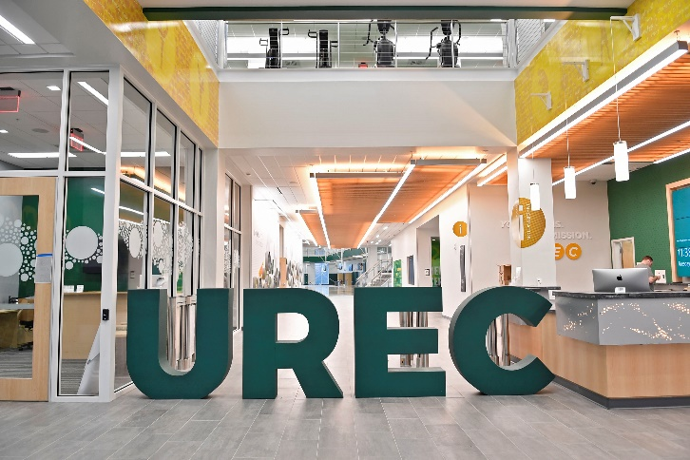

At UREC, the mission is to engage the University community through recreational programs, activities, and facilities, and this facility is designed to do just that, by encouraging patrons to lead a healthy and active lifestyle!

**Belk Gymnasium**

The Belk Gymnasium serves as the primary auxiliary space for indoor recreation, and features multipurpose courts for basketball, volleyball, and badminton; an indoor swimming pool; two racquetball courts; a group fitness studio; and lockers for students, faculty, and staff. It also houses newly renovated classrooms, a weight room and Athletic Trainer for Sport Club athletes, and an auditorium for meetings and presentations.

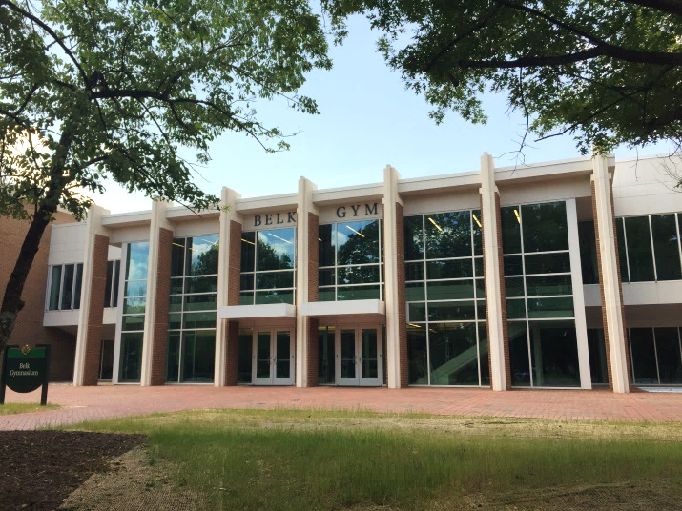

**Student Activity Center**

The James H. Barnhardt Student Activity Center (SAC) is a multi-purpose facility designed to meet the diverse social, cultural, and recreational needs of students at UNC Charlotte. The SAC is home to the Halton Arena, a 9,000 seat venue hosting athletic events, concerts, lectures, and a variety of other University functions.

Retractable seating in the area folds back to reveal an indoor climbing wall and four recreational courts that may be used for Intramural Sports, Sports Clubs, or for special events including job fairs, trade shows, etc. In addition to recreational offerings, the SAC also serves as a meeting place for students and the campus community. The third floor of the SAC consists of a large and gracious hospitality area that can be subdivided into five separate meeting salons. Adjacent to the hospitality area is a campus catering kitchen, serving the special events in the SAC as well as other campus events**.**

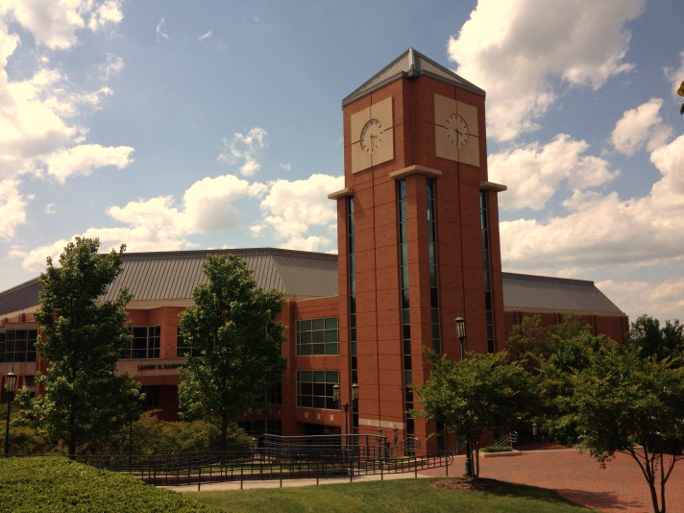

**Outdoor Facilities**

**Northeast Recreational Field Complex (NRFC)**

The Northeast Rec Field Complex or NRFC, features over 21-acres of synthetic turf fields for soccer, football and softball with lights for night-time use. NRFC is home to several intramural sports as well as open recreation opportunities, and can be used for sport clubs and special events.

**Hayes Recreational Field Complex**

Located off Phillips Road above the Wells Fargo Field House, the Hayes Rec Field Complex is home to three Rec Services fields - two are natural grass (Fields 11 and 12) and one (Field 13) is synthetic turf. All fields are fenced-in and lighted for night-time use. These fields are the home of many Sport Clubs, but are also available for reservation through CRES (Conferences, Reservations, and Event Services).

**C.O.R.E.**

The Callisthenic Outdoor Recreation Equipment (C.O.R.E.), is conveniently located adjacent to the on-campus greenway and near Belk Residence Hall. The equipment (i.e., pull up, parallel, and dip bars, ab benches, and more) can diversify your outdoor workout experience on campus. The C.O.R.E. was made possible through a partnership with UREC and the Levine Scholars Program.

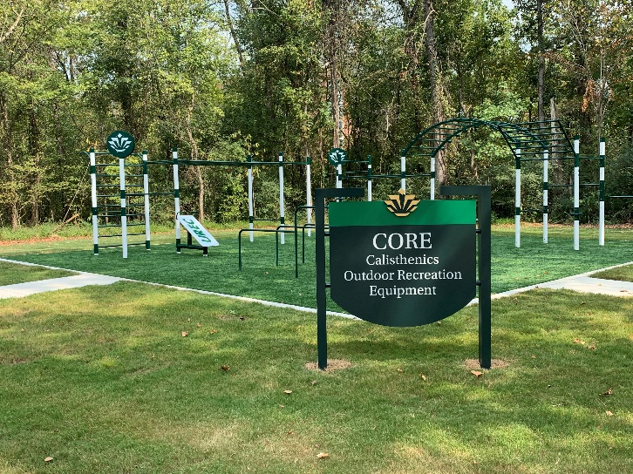

**Auxiliary Services**

**aux.charlotte.edu**

In support of the University’s educational mission, Auxiliary Services provides goods and services to meet the needs of the campus community. These include:

* Multi-function 49er ID system
* Dining venues and meal plans
* On-campus bookstore
* Printers and copiers
* Parking and transportation services
* Mail and package services
* Passport services
* ATM stations and vending machines
* Laundry and Dry Cleaning locker pick-up and drop-off service

**49er ID Card**

Every student’s 49er Mobile ID displays a photo, name, and a unique student ID number (different from a Social Security number for privacy reasons). The 49er Mobile ID proves that the student is a member of the campus community and entitled to certain services.

### A 49er ID card allows access to:

* Campus housing
* Campus activities and programs
* Athletic events and recreational facilities (i.e., Student Activity Center, Belk Gym, UREC)
* Computer labs
* Student Health Center

#### **The 49er Mobile ID also provides:**

* Meal plan access
* Library privileges
* Secondary credential for virtual parking privileges
* CATS All-Access Transit Pass

#### **And holds funds for:**

* 49er Account
* Optional Dining Account

### To get a 49er Mobile ID, students need:

* A student ID number that begins with 800 or 801 (assigned at acceptance; appears on the acceptance letter)
* To be registered for classes
* To download the Transact eAccounts app
* To upload your ID photo in the Transact eAccounts app

Entering freshmen and transfer students will provision their 49er Mobile ID during New Student Orientation. Physical 49er Cards may be obtained at the 49er Card Office in the Popp Martin Student Union.

The 49er ID can only be used by the student to whom it is issued. Misuse of the identification card will result in disciplinary action. There is a $20 fee to replace lost/stolen identification cards. For additional details, visit aux.charlotte.edu/49er-card.

## 49er Account

## The 49er Account resides on the UNC Charlotte 49er ID. Students deposit funds to activate the account. The 49er Account may be used at over 100 locations including:

## All campus dining locations including athletic events and campus convenience stores

## All campus retail locations: Barnes & Noble Charlotte, NinerTech, Campus Salon, Union Station and REPROS Copy Center

## Atkins Library (fines)

## Parking and Transportation Services

## Mail & Package Services

## Campus vending machines and Smart Markets

## Self-service copiers and pay-for-print printers in the library and labs

The 49er Account spends like cash for products and services all over campus but can’t be used for cash advances or purchases off-campus. A 49er Account is safe, secure, can’t go into negative balance, and won’t incur fees like overdraft charges.

There are four ways to deposit funds onto the 49er account

1. Online:

charlotte-sp.transactcampus.com/UNCC/AnonymousHome.aspx

1. In person: Visit the 49er Card and Meal Plan Office in Popp Martin Student Union
2. By mail: Send check or money order to the 49er Card Office, 9201 University City Blvd., Charlotte, NC 28223. Be sure to include the student's UNC Charlotte ID number and make checks payable to UNC Charlotte – 49er Account.
3. VTS machines: Located on the first and second floors of the Atkins Library and the first floor of the Popp Martin Student Union. VTS machines accept cash deposits only to the 49er Account and do not dispense change.

**Bookstore**

Located in the Student Union, Barnes & Noble Charlotte offers: new and used textbooks and textbook rental (with online ordering and pre-pack services); general interest and children’s books; school supplies; computer software; greeting cards and gifts; and the largest selection of UNC Charlotte apparel, gear and merchandise available. More information is available online at aux.charlotte.edu/bookstore and charlotte.bncollege.com.

**REPROS Copy Center**

UNC Charlotte has a pay-for-print system in most computer labs and in the Atkins Library. A 49er Account is required to pay for print jobs in these areas. The 49er Account may also be used at the REPROS Copy Center for other copying services such as binding, wide-format printing and presentation services. REPROS offers full-service and self-service reprographics, and is located on the lower level of the Prospector building. For details, visit aux.charlotte.edu/copy.

**Dining on Campus**

UNC Charlotte offers a wide variety of dining options in different locations across campus. From buffet-style dining at Crown Commons and SoVi to retail dining at over 20 locations, students find something that suits their taste, budget, and food preferences. A number of flexible meal plans suitable for resident students and commuters are available. For additional details, visit aux.charlotte.edu/dining.

**Mail & Package Services**

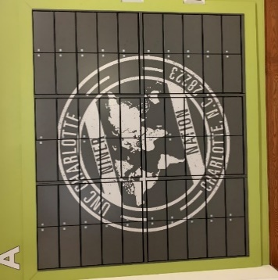Mail & Package Services is a fully-operational Postal Contract Station, capable of services equivalent to that of a U.S. Post Office. Packages are shipped and received through the United States Postal Service. Mail & Package Services handles and distributes mail for residential students and offers campus mailbox rentals. For additional details, visit aux.charlotte.edu/mail.

**Union Station**

Union Station in Popp Martin Student Union provides shipping, U.S. Passport, and custom balloon services.

Services offered include:

* Package shipping service (USPS, DHL, FedEx)
* Stamps and shipping supplies
* Money orders
* Campus mailbox rental
* Kodak® photo kiosk
* Self-service copier
* Fax services
* Balloons

**Passports**

Union Station has also been certified as a Passport Acceptance Facility to process U.S. Passports and submit them for Department of State approval. Passport application requires proper documentation. For details, visit aux.charlotte.edu/mail-package/union-station. Passport photo service is also available.

**Parking and Transportation Services**

Parking and Transportation Services (PaTS) provides parking management and transportation services for UNC Charlotte students, faculty, staff, and visitors.

**Parking Permits**

The PaTS office is located in the Facilities Operations/Parking and Transportation Services Building. All campus parking requires the purchase of a University virtual parking permit or payment in visitor areas. Virtual parking permits may be purchased online at pats.charlotte.edu. Permits do not guarantee proximity parking, nor do they reserve a specific parking space in any lot or deck.

**Permit Types**

* **Annual Full-time Commuter** (C), on-campus **Resident** (R), and **Faculty/Staff** (FS)
* **Night permits** are valid only after 3 p.m.

A limited number of reduced permits are available for commuter students and staff who are willing to park in a remote lot. Discount Lot 27 is a “walking lot” with no bus service within 1/10 mile. Additionally, there are discounted North Deck Only permits or Lot 6A permits available to commuter students. Niner Transit services North Deck and Lot 6A.

Complete permit information including prices, permit types, and where each permit allows you to park; and parking rules and regulations are available online at pats.charlotte.edu. For information on fees for motor vehicle registration and parking, see the section on "Financial Information” in this *Catalog*.

**Parking Availability**

The Parking Availability tool allows commuters to see parking deck capacity in real time. Save time by using parkingavailability.charlotte.edu to create your parking plan prior to heading to campus.

**Niner Transit Bus Service**

Buses operate seven days a week, except on observed holidays and when the campus is closed: 6 a.m.-2 a.m. weekdays and 9 a.m.-2 a.m. weekends. Niner Transit operates fare-free bus routes that serve the main areas of campus and provide safe, reliable, and ADA-compliant transportation. For route maps and schedules, visit pats.charlotte.edu.

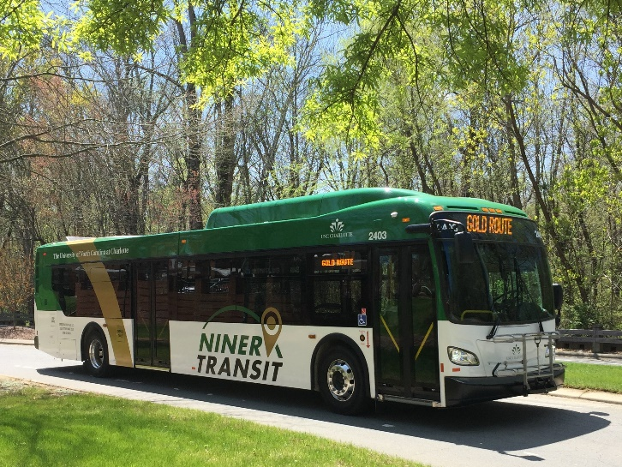

**PassioGO!**

PassioGO! is a free smartphone app that provides real-time transportation tracking information for campus buses and ADA Paratransit vehicles. The app is compatible with Android and iOS operating systems, phones, or tablets, and is available online at passiogo.com.

**Niner Paratransit Service**

PaTS offers disability transportation service Monday through Friday from 6:30 a.m. to midnight during the Fall and Spring semesters. Service is limited to those with temporary and permanent mobility impairments. Riders must register for the service through the Office of Disability Services at 704-687-4355. Forms are available on the PaTS website at pats.charlotte.edu/transportation/disability-paratransit and at the Office of Disability Services or the PaTS office. For additional information, contact PaTS at 704-687-5636.

**Bike and e-Scooter Rentals**

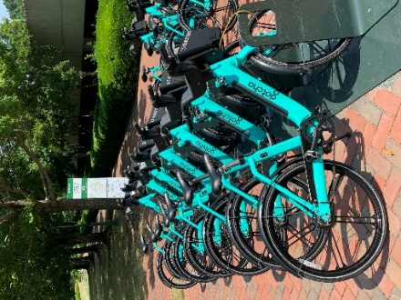Pedal-assist bikes and e-scooters are available for short-term rental at hub locations all over campus. Download the Leap App, available on iOS and Android, to find and rent available bikes and e-scooters. Additional information about the program is available online at pats.charlotte.edu//transportation/e-scooters-and-bikes.

**Bike Lockers**

Bike lockers are available to current students, faculty, and staff. They are located in CRI, North, and South Village parking decks, and Lot 27. Lockers are supplied at no charge to students, faculty, and staff who have a valid full-year UNC Charlotte parking permit. Otherwise, lockers may be rented for $15 a semester or $40 for the year.

**Charlotte Area Transit System (CATS)**

The Miscellaneous Transportation Service Charge entitles students to ride on Charlotte Area Transit Systems LYNX light rail, CATS buses, CATS airport sprinter service and STS service (requires individuals to sign up for Special Transportation Service) without having to pay a fare.

To ride LYNX light rail, students simply show a 49er Mobile ID, if requested by a fare inspector. LYNX light rail services the Main Campus, Center City, Pineville, and many locations in between. Routes and schedules are online at charlottenc.gov/cats/rail/Pages/default.aspx.

For CATS buses, students show their 49er Mobile ID upon entering a bus.

**Dean of Students Office**

**dso.charlotte.edu**

The Dean of Students Office is a department within the Division of Student Affairs and serves as a key link between students and other areas of campus life. The mission of the Dean of Students Office is to enhance student learning and interpersonal growth by serving as a resource for students and families navigating the Niner Nation journey. Each program unit within the Dean of Students Office has a specific mission, but one common goal: to provide education, outreach, and support that maximizes opportunities to fully participate in and authentically contribute to the University experience. Program areas housed within the Dean of Students Office include: Identity, Equity, and Engagement; Niner Finances; Student Assistance and Support Services; Student Accountability and Conflict Resolution; Student Transition and Support; and Veteran Services. The Dean of Students Office, along with its programs and services, is the central point of contact when individuals want to get involved, need to resolve a conflict, have questions about policies and procedures, or are trying to identify campus resources and information that will put them on the path to success. Through dedicated, passionate, and knowledgeable staff, the Dean of Students Office provides guidance and advocacy for students, empowers independent thinking and problem solving skills, exposes students to diverse perspectives, encourages personal accountability, and cultivates civility and global citizenship.

The main Dean of Students Office suite is located in King 217. For more information, visit dso.charlotte.edu.

### Identity, Equity, and Engagement

The mission of the Office of Identity, Equity, and Engagement (IEE) is to support students who hold historically minoritized identities in an effort to enhance a university culture that embraces inclusive excellence. IEE strives to champion efforts for students from historically minoritized communities to be seen and celebrated through programs rooted in cultural and social equity. IEE aims to provide affirming and transformative spaces for students to engage, show up as their authentic selves, and form a sense of belonging at UNC Charlotte. The office promotes interaction with the University and Charlotte community through identity development of students by offering peer mentoring, leadership opportunities, and ongoing education, programming, and training which explore the many facets of diversity, equity, and social justice.

The Office of Identity, Equity, and Engagement coordinates programming and support for students, including cultural heritage celebrations, diversity education and leadership training, LGBTQ+ outreach and education; and opportunities for engagement with 100+ identity-based student organizations. Visit online at identity.charlotte.edu.

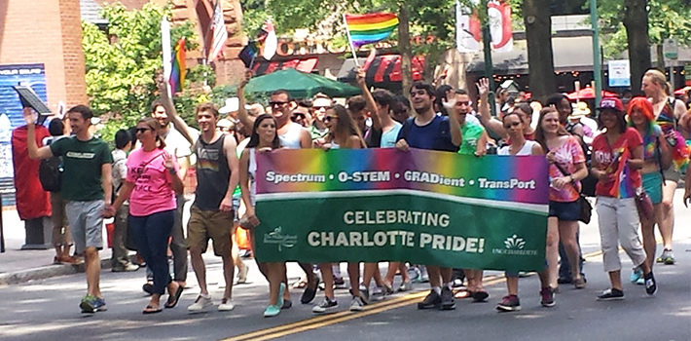

#### **LGBTQ+ Programs and Services**

The Office of Identity, Equity, and Engagement (IEE) provides multiple programs and services that serve and support LGBTQ+ students and advocates. First-year LGBTQ+ students can engage in Queer Year 1, a cohort-based program aimed to connect first year LGBTQ+ students together and to resources on campus. Students can engage and connect with fellow students through monthly LGBTQIA+ Community Chats and For Us: A QTBIPOC Student Space. The IEE also oversees the Lavender Lounge, which is a space for LGBTQ+ students and allies to connect and build community. The IEE works collaboratively with various offices/departments on campus to provide programs and resources such as LGBTQ+ History Month, the Preferred First Name process, and Gender Affirming Housing. For more information, visit identity.charlotte.edu.

Students who are interested in learning how to be an advocate for their LGBTQ+ peers can attend Friendly Peer Training throughout their time here at UNC Charlotte. Students can also attend a variety of educational events regarding LGBTQ+ identities throughout the academic year outside of Friendly Peer Training.

#### **Students Achieving First-Year Excellent (SAFE)**

SAFE is a peer mentoring program designed to assist students’ academic and social transition through their first year of college. The SAFE program connects new students with upper-class mentors who serve as role models during the first year of college while providing academic and student development programming to address needs in a holistic manner. SAFE is open to all first-year students, but has a unique emphasis on students from historically minoritized backgrounds (students of color, first generation students, low socioeconomic status, etc.). Visit online at safe.charlotte.edu.

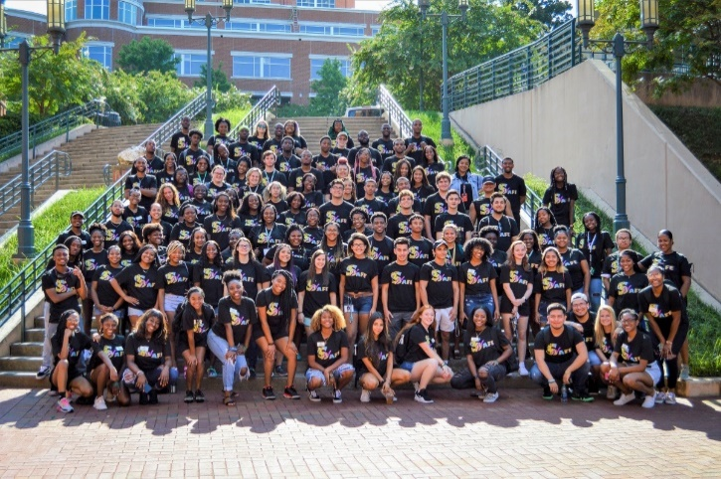

Additionally, the office assists in the holistic development of UNC Charlotte students by providing avenues to explore socioeconomic status, race, ethnicity, as well as sexual, gender, religious, and spiritual identity and expression. The office serves as an equity and justice resource for both University and community support sources. Staff in the office also provide feedback and guidance to University administrators regarding best practices for inclusive institutional practices, policies, and procedures. Visit identity.charlotte.edu or the office in the Popp Martin Student Union for more information.

**Transition & Success Initiatives**

**Gold Rush**

Gold Rush is the official welcome week program taking place in August and January each year. Welcoming both new and returning students to campus, Gold Rush is a University-wide effort to assist students in successfully transitioning to campus each year.  Gold Rush aims to instill a sense of Niner Pride, teach campus traditions, and expose students to campus resources and opportunities for involvement. A full schedule of Gold Rush activities is available online at tsi.charlotte.edu.

**Niner Nation Family**

Niner Nation Family is intended to engage UNC Charlotte parents, family members, and student supporters through quality services and programs. These services and programs facilitate positive relationship-building, enhance communication between families and the University, and create an inclusive and comfortable environment. Our team believes that when families and supporters are informed and engaged, students benefit. Each of our programs and services strives to keep families and supports up-to-date on Niner Nation and connected to our community. Various levels of involvement are available to all parents, family members, and supporters of current students. Join us by visiting tsi.charlotte.edu.

**Niner Finances**

Niner Finances was created to provide UNC Charlotte with the knowledge and skills necessary to make informed and sound financial decisions. Niner Finances also understands and embraces the fact that knowledge and skills alone do not guarantee financial well-being or security. Our office staff takes on an individualized approach to working with people to understand their emotions, attitudes, motivations, and lived experiences pertaining to their personal finances. By providing education, resources, coaching, and services that align knowledge with personal orientation, Niner Finances helps to ensure long-term financial security of the individuals we serve. Visit online at ninerfinances.charlotte.edu.

**Student Assistance and Support Services (SASS)**

Student Assistance and Support Services (SASS) advocates for students experiencing a broad range of issues, concerns, or challenges interfering with a student’s ability to be successful academically or personally at UNC Charlotte. SASS can advocate for students who may have missed classes due to medical appointments, personal or family emergencies, military orders or certain court orders, but do not have the authority to grant specific academic accommodations within the classroom setting. SASS can provide verification of these types of absences via an online request form and official supporting documentation. Faculty have full authority to provide academic accommodations and are encouraged to work with students directly. The SASS office also oversees both the partial and full withdrawal with extenuating circumstances processes during the current academic term. These academic options assist students who may need to reduce their course load or take a full break from academic work in a given semester. Extenuating circumstances may include medical or mental health concerns, personal emergencies, or military orders.

Students can seek out support directly in the SASS office or may be referred to the office by faculty, staff, or other community members. Professionals within the office also provide consultation to faculty and staff needing guidance regarding a student issue or concerning student behavior, and guidance and support to parents and family members seeking help on behalf of their students. To learn more about these services, along with the additional services provided by SASS, visit sass.charlotte.edu.

**Student Accountability and Conflict Resolution**

The mission of Student Accountability and Conflict Resolution is to uphold academic and community standards, encourage personal accountability and responsible decision making; promote student learning; and reduce and prevent behavior that undermines student success and community safety. We are committed to providing a fair, impartial, and efficient process facilitated through compassionate conversations in which students are heard, respected, and treated with dignity.

As part of their individual responsibility to the University community, all UNC Charlotte students are expected to be familiar with University Policy 406, the Code of Student Responsibility, and University Policy 407, the Code of Student Academic Integrity. Any person may report an alleged violation(s) of the Code of Student Responsibility or Code of Student Academic Integrity online at incidentreport.charlotte.edu. Individuals may report crimes or incidents involving imminent threat of harm to Police and Public Safety at 704-687-2200. Visit accountability.charlotte.edu for more details.

**Veteran Services**

Veteran Services coordinates support services for military veteran and dependent students such as assistance with University administrative support, veteran-friendly employment, peer mentoring, and veteran service organizations. In addition, the Office of Veteran Services is responsible for administering and certifying veterans benefits through the Veterans Administration Office. The Veteran Services office also plans events on campus in honor of our nation’s servicemen and servicewomen. Visit online at veterans.charlotte.edu.

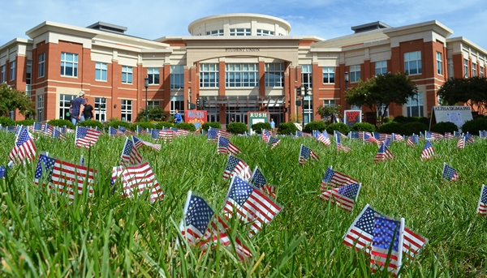

**Environmental Facilities and Services**

**Botanical Gardens**

The UNC Charlotte Botanical Gardens, located on campus, consist of the McMillan Greenhouse, the 7-acre Van Landingham Glen, and the 3-acre Susie Harwood Garden. The mission of the gardens is to inspire a love for plants and nature through programming, classes, and botanical displays. The gardens were begun in 1966 by the late biology professor emeritus, Herbert Hechenbleikner, to serve as a living classroom and have evolved into a multifaceted campus and public resource. Collections include orchids, carnivorous plants, succulents, native plants, tropicals, and native collections including hardy outdoor trees, shrubs, wildflowers, and ferns. The outdoor gardens are open seven days a week during daylight hours, and the greenhouse is open Monday through Friday from 9 a.m. to 4 p.m. Students and the public are invited to visit, free of charge. Visitors can check out a hammock at the greenhouse, or enjoy a picnic lunch at tables near the gazebo. The Gardens also offer classes and events throughout the year, including two annual plant sales in the Spring and Fall, and an annual Valentine’s Day orchid sale. The plant sales help to support the operations of the Gardens, where admission is always free. More information can be found online at gardens.charlotte.edu.

**Environmental Health and Safety**

It is the mission of the Environmental Health and Safety Office to support the University by working with all University community members to provide a safe and healthy working, teaching, learning and living environment. This is accomplished by providing high-quality, responsive, customer-focused environmental health and safety services to the campus community. It is our responsibility to develop environmental health and safety programs, maintain appropriate accident documentation, conduct safety inspections of all facilities and operations, audit safety programs, maintain all regulatory required reports, and generally work to reduce the risks of illness or injury.

All members of the University community share the responsibility to provide and maintain a safe and healthful campus environment and to reduce or eliminate known hazards. Each individual is expected to exercise appropriate care in the conduct of his or her activities to preserve the safety and health of self and others. For more information, please visit safety.charlotte.edu.

**Recycling**

UNC Charlotte students recycle! Started in 1990 by engaged student representatives, the recycling program has grown from collecting just aluminum cans to more than 40+ items on campus. Recycling is coordinated by the Office of Waste Reduction and Recycling and is available in academic and administrative buildings, in many outdoor areas, and in all residence halls on campus. In the academic and administrative buildings, recycling can be found in common areas, like hallways and lobbies. In the residence halls, there are centralized recycling bins in trash rooms or lobbies. Once recyclables are collected in rooms, students should bring them to the centralized bins for proper collection. Housing and Residence Life housekeepers pick up the recycling and transport it to the loading docks of the residence halls for pickup.

The following items can be recycled on campus:

* Aluminum cans
* Steel and tin cans
* Glass bottles and jars
* Plastic bottles
* Paper / junk mail / magazines
* Cardboard
* Empty pizza boxes

The Office of Waste Reduction and Recycling also supports a “Weird Recycling Center” in the Popp Martin Student Union, South Village Dining Hall and Prospector. Here you can bring empty and clean plastic bags, cords/cables, batteries, printer cartridges, eyeglasses, and CDs for recycling.



There is also a recycling area for mail and packaging products located at Mail Services in Prospector. Cardboard boxes, plastic packaging, and packing peanuts can be recycled in this location.

In addition to collecting recycling on campus, the Office of Waste Reduction and Recycling provides other waste reduction efforts, like composting and a reuse program called “Free Store” that happens every August and January. The Office of Waste Reduction and Recycling also supports zero waste football at the Stadium and works closely with the Office of Sustainability on Zero Waste Initiatives.

For more information or to get involved, visit recycling.charlotte.edu and follow @unccrecycling on Instagram and Facebook.

**Health, Wellness, and Counseling Services**

**Student Health Center**

The Student Health Center provides comprehensive healthcare services to enrolled students at UNC Charlotte. Services include primary medical care, disease prevention, and various specialty services, including allergy injections, immunizations, gynecology, lab and x-ray, and STI screening. The Student Health Center is staffed by a team of physicians, physician assistants, nurse practitioners, psychiatrists, and a registered dietician. The on-site Pharmacy has over-the-counter items and fills prescriptions. Students can have their prescriptions transferred to the pharmacy to assist with continuity of care.

The Student Health Center functions by appointment; this eliminates long waits and assists students in scheduling medical services around class schedules. Students are expected to be 15 minutes early for appointments.

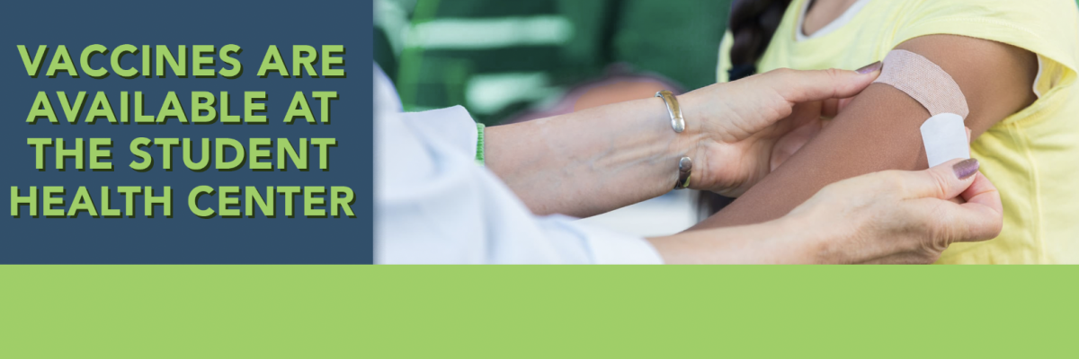

After-Hours Nurse Triage services are available by phone when it is not open, including nights, weekends, and holidays. There are a number of urgent care centers and a major hospital within a few miles of the University, if medical care is needed when the Student Health Center is closed.

The health fee covers the cost to see a provider and some other services. There are charges for x-ray, pharmacy, laboratory, injections and special procedures. Payment may be made by cash, check, credit card, or transferred to the student's University account. The Student Health Center files insurance for those students who have the Student Blue Health Insurance plan. For more information, visit the Student Health Center website at studenthealth.charlotte.edu or call 704-687-7400.

Students are required to either provide proof of insurance or purchase a University Student Health Insurance Plan. All students will be charged for the Student Health Insurance Plan; however, students will have this charge removed if they complete the waiver by the deadline. The waiver process can be found under the Insurance tab at studenthealth.charlotte.edu.

North Carolina law requires students to have proof of immunizations. This must be provided to the Student Health Center upon registration. Students whose immunizations records are not complete are subject to being withdrawn from their classes. Please see “Immunization Requirements” in the Admission to the University section of this *Catalog* or visit studenthealth.charlotte.edu under the Immunizations tab.

**Center for Wellness Promotion**

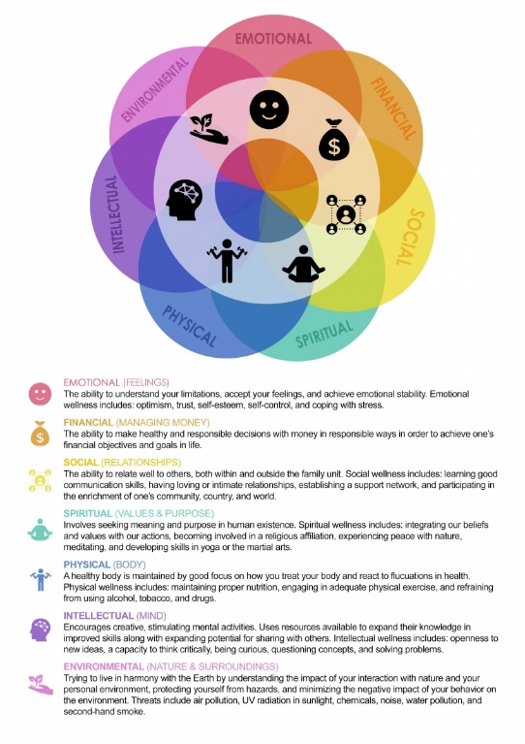The Center operates from a public health model and utilizes prevention and health promotion strategies to empower students to make informed decisions about their personal health and well-being. The team of multidisciplinary professionals addresses issues such as alcohol use, drug use, recovery from substance use disorders, tobacco cessation, sexual health, sexual and relationship violence, and a variety of other wellness topics that affect college students.

This is done through health education workshops and events, campus-wide wellness promotion initiatives, and individual consultations with the team members. The Center also coordinates the Charlotte Recovery Program, which provides clinical services and other support to students in recovery from substance use disorders, as well as services for students who want to change their relationship with substances.

The Center for Wellness Promotion offers a variety of opportunities for students to get involved with wellness promotion initiatives, including undergraduate student employment, graduate assistantships, and internships within the department.

More information about the Center may be found by visiting wellness.charlotte.edu.

**Counseling and Psychological Services (CAPS)**

The Center for Counseling and Psychological Services (CAPS) at UNC Charlotte supports the holistic well-being and academic success of students and contributes to a healthy and inclusive campus climate. This is accomplished by providing short-term individual and group counseling, crisis management, consultation, referral services, and educational and preventive initiatives for the campus community. In addition, the Center supports the academic mission of the University by serving as a training site for graduate students and supports scholarly activity and professional development of staff.

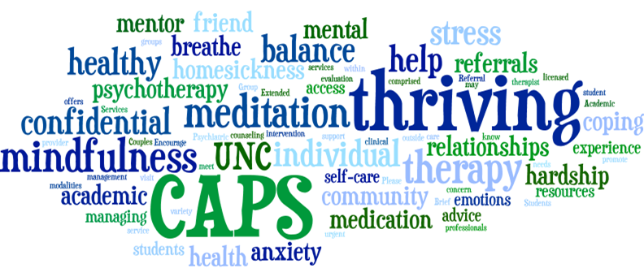

CAPS aspires to create an affirming, accessible, and safe environment that celebrates human diversity. The Center understands diversity, which includes but is not limited to: race, ethnicity, gender identify and expression, sexual identity, sex, age, socio-economic status, religion, ability, nationality, and language. CAPS is dedicated to social justice through increased awareness of the effects of oppression, prejudice, and discrimination.

Counseling provides an opportunity for individuals to improve personal skills, build resiliency in the face of adversity, develop increased confidence, overcome psychological issues that can hinder personal effectiveness, learn to make better decisions, and acquire a keener awareness and appreciation of their needs and the needs of others. In a personal interaction with a counselor, a student feels supported to validate, explore, and express feelings, examine values and ways of thinking about the world, reflect on and change patterns of behavior, and work toward making healthy changes to meet specific personal and interpersonal goals.

For many students, relationship or other developmental issues are central concerns. Others may be experiencing specific psychological problems such as depression, anxiety, eating disorders, use of alcohol and other drugs, or difficulties in adjustment. Licensed psychologists and social workers as well as advanced graduate students under the supervision of licensed staff are available to consult with students about these concerns.

All currently enrolled students are eligible for an initial assessment. This first session is intended to assess the student’s need, and the student and counselor decide how best to meet those needs. Follow-up services may consist of individual or group counseling or psychoeducational workshops at CAPS and/or a referral to an on-campus or off-campus service. Information shared by student clients is confidential in accordance with ethical guidelines and the laws of the state of North Carolina.

Outreach and consultation are important services provided by CAPS. Staff members are available to consult with faculty, staff, parents, loved ones, and students who have concerns about a student. Outreach activities, usually focusing on some aspect of personal, interpersonal, or group development, include programs conducted outside CAPS to meet the needs of a class, group, or organization.

Initial counseling appointments may be arranged by calling the Center at 704-687-0311 or visiting the Christine F. Price Center for Counseling and Psychological Services in the Student Health complex. More information about CAPS and its services can be obtained by visiting caps.charlotte.edu.

**Housing and Residence Life**

**housing.charlotte.edu**

Housing and Residence Life (HRL) offers a variety of housing options including traditional, suite, and apartment style. Living on campus helps you build your foundation for success at UNC Charlotte.

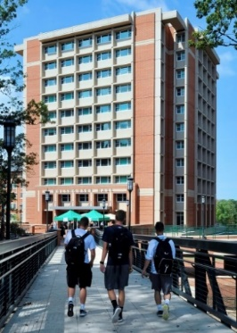**Traditional**

Within traditional style housing there are two configurations: singles (one person/one bedroom) and doubles (two person/one bedroom). Each resident is provided a bed (mattress and bed frame), desk and chair, dresser and a closet or wardrobe. Traditional style housing features community bathrooms shared by residents of each floor, as well as community lounges and study rooms. Laundry facilities, a kitchen and vending are also provided in each building.

**Suites**

Within suite style housing there are five configurations: one person/one bedroom, two person/two bedroom, three person/three bedroom, four person/four bedroom, and four person/two bedroom. Each suite style unit contains bedroom(s), a shared living room and shared bathroom(s). Each resident is provided a bed (mattress and bed frame), desk and chair, dresser and a closet or wardrobe. In most suite shared living rooms, a couch and tv stand is provided (note: shared space furnishings vary by hall).



**Apartments**

Within apartment style housing there are two configurations: one person/one bedroom and four person/four bedroom. Each apartment style unit contains bedroom(s), a shared living room, a shared kitchen and shared bathroom(s). Each resident is provided a bed (mattress and bed frame), desk and chair, dresser and a closet or wardrobe. In most apartment shared living rooms, a couch and tv stand is provided, in the shared kitchen a full size fridge, microwave, stove/oven and either a small table and chairs or bar stool is provided (note: shared space furnishings vary by hall).

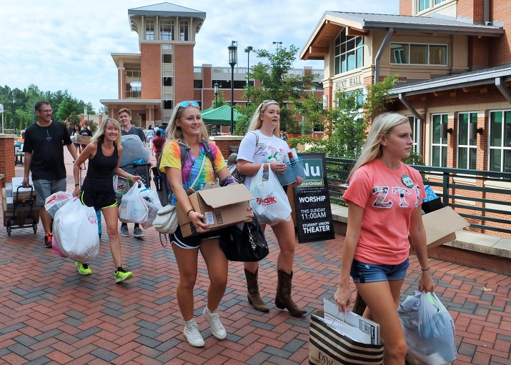

**Greek Village**

Greek Village is comprised of 13 houses and is home to UNC Charlotte's sororities. In addition, there are houses reserved for non-greek residents. Each house has a large living/chapter room, dining room, office and full kitchen for common use and sleeps either 28 or 14 residents.

**Summer Housing**

Students eligible to live in summer housing must be registered for summer classes at UNC Charlotte or enrolled at UNC Charlotte in the spring semester and pre-registered for class in the upcoming fall semester. For information about summer housing, visit [housing.charlotte.edu/apply/summer-housing](https://housing.charlotte.edu/apply/summer-housing).

**Applying For Housing**

Living on campus at UNC Charlotte is very popular, and demand is high. To support the success of incoming students, HRL prioritizes applications from entering first time in college (FTIC) students, new transfer and international students, then continuing students as available space allows. In addition, assignments are made according to a combination of factors including availability, date of completed application, roommate requests and building/room preferences. To apply, visit [housing.charlotte.edu/apply](https://housing.charlotte.edu/apply/apply). A $100 non-refundable housing application fee is required and does not guarantee a housing assignment.

**Accommodations for Students with Disabilities**

Housing and Residence Life works in coordination with the Disability Services Office to provide accommodations to any resident with differing abilities or special needs. In order to ensure that all requests are properly handled in accordance with UNC Charlotte's policies and procedures, as well as State and Federal laws, we kindly ask that students contact the Office of Disability Services to submit their requests.

**International Programs**

**oip.charlotte.edu**

**Office of International Programs**

The Office of International Programs (OIP) strives to strengthen international education and global learning at the University as well as in the Charlotte community. On campus, it seeks to make international understanding, intercultural competency and global awareness a fundamental part of the curriculum and an integral part of campus life through innovative and accessible programming. The Office of International Programs serves as a center of leadership and responsibility for the international role and mission of the University. OIP constituent units include OIP Administration (OIPA), the Office of Global Education and Engagement (OGEE), the Office of Education Abroad (EA), the International Student and Scholar Office (ISSO), the English Language Training Institute (ELTI), and the Office of Intercultural and Educational Experiences (OIEE). In addition, OIP is the campus host for the World Affairs Council of Charlotte.

**OIP Administration**

The Office of International Programs Administration unit (OIPA) includes the Associate Provost, the finance office, and administrative staff. OIPA provides overall leadership and direction for the Office of International Programs and its constituent units; develops, supports, and organizes a wide range of on- and off-campus programming; supports faculty development through various initiatives; guides the development of institutional agreements and ongoing partnerships with foreign universities; and provides leadership and advice to promote campus internationalization efforts.

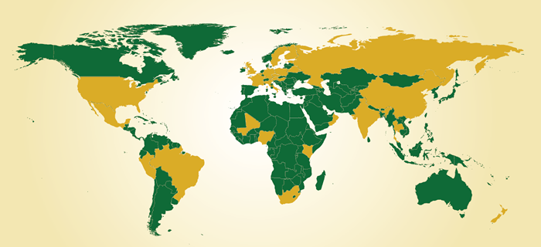

**Office of Global Education and Engagement**

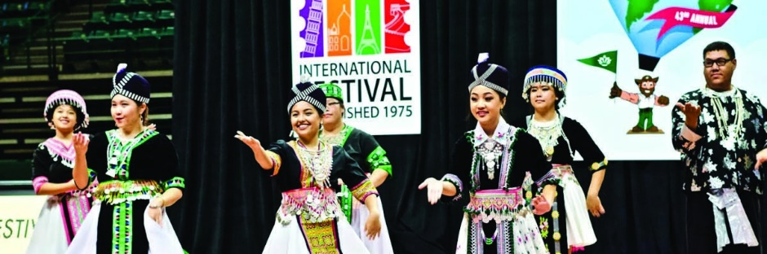The Office of Global Education and Engagement (OGEE) orchestrates academic and co-curricular opportunities to infuse global and intercultural learning for University constituencies and the Charlotte community. OGEE facilitates student development and learning through its campus international and cultural programming, as well as public service. As such, OGEE implements various internationally focused campus events including, but not limited to International Education Week, International Women's Day, UNC Charlotte International Festival, International Speaker Series, and activities associated with the Mu chapter of the Phi Beta Delta Honor Society for International Scholars.

OGEE offerings promote global learning and engagement. OGEE (1) implements the Global Engagement Scholars Program (GESP), designed to strengthen global competencies and understanding; (2) oversees the Global Gateways on-campus internationally themed living community, offering students the opportunity to live together while participating in intentional cultural learning activities; (3) implements country-culture workshops to enhance the community's global understanding and (4) coordinates the Globally Networked Learning (GNL) program which promotes access to global learning opportunities to all through virtual international collaborative projects in courses that are taught by UNC Charlotte and overseas faculty.

In addition to campus-based programing, OGEE supports OIP's public service work to initiate and respond to the international needs and interests of the University and the Charlotte area-wide community. Current programs include: (1) Great Decisions, an annual series of lectures/discussions on key policy issues; (2) cross-cultural training, custom-designed workshops that focus on appreciation for other cultures and development of skills in effective communications across cultures; and (3) International Festival, a celebration of cultural diversity and "marketplace" style program featuring international foods, music, and dance from more than 50 countries.

**Office of Education Abroad**

The Office of Education Abroad (EA) is committed to providing quality, accessible global learning opportunities to all students to enhance their studies in an experiential environment abroad. Further, EA supports faculty initiatives to create innovative study abroad, exchange, and virtually connected international programs to enhance learning and student success.

Students are encouraged to consider the benefits of an academic program through study or experiential learning abroad. In addition to University-administered programs, EA has partnerships with program providers facilitating access to additional programs from a worldwide framework of opportunities. Students can select from year-long, semester, summer, or other short-term programs.

In addition, EA provides students the opportunity to implement theoretical knowledge into practice beyond the UNC Charlotte classroom, challenge their assumptions of and learn more about different cultures, and explore their own relationship with the changing global landscape while making progress toward their degree requirements.

**International Student and Scholar Office**

The International Student and Scholar Office (ISSO) provides support, services, and programs that assist international students visiting scholars and international faculty in achieving their educational, professional and personal goals while fostering an appreciation for a culturally diverse learning environment in the larger University community.

UNC Charlotte hosts a vibrant international community. About 1,500 non-immigrant international students and more than 100 international scholars and faculty, representing nearly 100 countries around the world, study, teach, and conduct research at UNC Charlotte. The ISSO conducts orientation, cultural programming, and individual advising; provides assistance with navigating complex immigration regulations; maintains institutional compliance; supports and advocates for the international community. International and/or U.S. domestic faculty or staff who wish to learn more about immigration matters or work with international students may attend various workshops offered regularly. The ISSO also supports diversity programs to encourage international and domestic students' interaction, such as the International Coffee Hour, Friendship and Culture Exchange Program, and the Cultural Ambassadors programs.

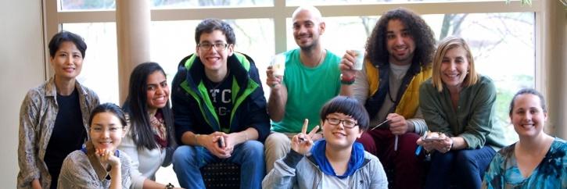

**English Language Training Institute**

The English Language Training Institute (ELTI) serves as our University's intensive English language program (IEP) by introducing and refining the English language and cultural adaptation skills that students will need to succeed in their academic careers. Students complete the program well prepared for academic study at UNC Charlotte or other U.S. colleges and universities.

The ELTI offers six levels of English language instruction to participants from a diverse range of countries each semester. In addition to benefitting from 18 hours of instruction each week, students have the opportunity to attend UNC Charlotte academic classes, meet with U.S. conversation partners, and tour area schools and sites of cultural interest. On average, students study with ELTI for two semesters.

ELTI also evaluates new faculty and graduate teaching assistants at UNC Charlotte for whom English is an additional language. An enrichment program is offered each semester for graduate teaching assistants who quality. The course reinforces communication skills that are vital in the classroom, such as incorporating functional language cues, using accurate vocabulary, and improving pronunciation.

**Office of Intercultural and Educational Experiences**

The Office of Intercultural and Educational Experience (OIEE) promotes intercultural awareness, education, and professional training by designing and implementing custom on campus short-term programs for both domestic and international partners.

Each program is developed in collaboration with institutional, regional, and overseas partners as well as University faculty to deliver strong, outcome-focused programs. These highly desirable learning experiences prepare individuals to be successful in an increasingly global society. Program offerings include a wide array of academic and professional development topics, such as education, leadership, marketing, STEM, and language immersion.

Each experience is custom-designed and infused with experiential learning and cultural, social, and recreational events, as well as opportunities for engagement with the Charlotte and University area-wide communities.

**World Affairs Council of Charlotte**

Founded in 1983, The World Affairs Council of Charlotte (WACC) serves as a community outreach program for the Office of International Programs at UNC Charlotte. By serving as a regional center for education and discussion of world affairs, WACC provides leadership for global thinking, understanding that a broad perspective is necessary for effective competition in the global economy and for responsible citizenship in an increasingly interdependent political world. The WACC hosts internationally renowned speakers to address topics ranging from economics to globalization to foreign policy.

The WACC also serves as a resource for the local school community, providing educational programming and scholarships. Each year, WACC awards nearly $35,000 through their Council Scholars program, which provides funds to area K-12 educators to support international education initiatives. In addition, WACC has established close ties with the local school districts, providing learning resources to local K-12 student populations. Since 1996, the organization has directly affected over 700 teachers and more than 75,000 students.

**Library**

**library.charlotte.edu**

The J. Murrey Atkins Library, the largest academic research library in the Southern Piedmont region and a member of ASERL (the Association of Southeastern Research Libraries), is the center of intellectual life at UNC Charlotte. The Library’s mission is to advance the scholarly and creative endeavors of the University and the greater Charlotte community by providing exceptional collections, spaces, services, and technologies. It inspires innovation, supports research, and cultivates scholarship.

**Research**

In addition to holding over 3.3 million physical items, including almost 13,000 rare books, the Library continuously develops its digital collections and currently provides access to nearly 200,000 electronic journals, 400 databases, and 1.4 million electronic books. Expert subject/liaison librarians offer a variety of research services: course assignment, project, and research paper help; citation management assistance; information literacy classes; support within Canvas courses, and much more. Students get assistance from a subject librarian through live chat, email, phone, in person at the Information and Research Desk on the 1st floor, and one-on-one consultations for deeper, subject-related research guidance. Students and classes conduct research with rare and archival materials in Special Collections and University Archives on the 10th floor.

**Services**

*Ask Atkins* assists students, faculty, and staff at three service desks and via live chat, email, phone, and text. The Information and Research Desk on the 1st floor is the main service point for locating, lending, renewing, and returning library material including laptops, Interlibrary Loan items, and Course Reserves material. Document delivery, book retrieval, and Interlibrary Loan are available to students, faculty, and staff to facilitate access to library collections and research material. Research services include face-to-face and online assistance with all stages of the research process, research instruction sessions and workshops, and data research services. “Atkins kiosks” throughout the building enable users to check out their own library materials, make a study room reservation, and chat with staff. The Office of OneIT maintains its walk-up help desk in Room 140C, while the University Writing Resources Center offers some of its hours in G31. Tutorial Services conducts some tutoring sessions on the ground floor.



**Facilities**

The Library features study and collaboration spaces for all needs including 57 reservable group study rooms, Graduate and Silent Study rooms, Family Friendly study rooms, and collaborative tables, seating areas, and enclosures throughout the building. The entire building features wireless access, and mobile hotspots can be checked out to use anywhere a wireless connection is needed. Library computers feature a variety of adaptive software supplemented by a dedicated room with assistive technologies next to the Information and Research Desk. Students can check out calculators, chargers, laptops dual monitors, iPads, and cameras. Atkins offers 715 loaner laptops, both PCs and Macs, at the Information and Research Desk. Students can experiment with new technologies (3D printers, cameras, etc.) from the Area 49 Desk, which supports the Visualization Lab, MakerSpace, Gaming Lab, EZ Video Studio, and other specialized spaces on the 2nd floor. A Photogrammetry Lab was recently added on the 1st Floor near the Information and Research Desk. Other features include device-charging stations and nap pods. Vending machines offer office supplies, coffee/beverages, and other food to supplement the offerings of the Starbucks on the ground floor. Students may bring their own beverages and food. Microwaves are available.

The Charles C. Hight Architecture Library is located on the 2nd Floor of the Storrs building, which houses the College of Arts + Architecture. The Hight Library collection includes: books, audiovisuals, periodicals, graduate thesis documents, drawings, and plans.

For more information and Library hours, visit library.charlotte.edu.

**Performing Arts**

Within the College of Arts + Architecture, the Departments of Dance, Music, and Theatre serve the educational needs of students and the cultural needs of Charlotte and the University community. It is the mission of these three departments to train students in performing arts-related fields and prepare them for careers across a broad professional landscape.  In addition, the departments provide numerous opportunities for non-majors to participate in the performing arts through classes, ensembles, and productions, which are open to non-majors. Together, the three departments present nearly 100 performances each year for the public and campus audiences.

**Performance Venues**

As UNC Charlotte’s primary facility for the arts, **Robinson Hall** is where the weeks and months of planning, programming, and behind-the-scenes work give way to presentation to live audiences. Performance in the College of Arts + Architecture is a form of research, rooted in the history of public presentation, but also projecting forward to suggest new definitions of “concert,” “program,” and “production.” Most importantly, each performance is a shared, communal experience of audience and artists.

Public performances reinforce our role as a resource to the arts community in Charlotte. More than an entertainment venue, Robinson Hall offers a space to challenge preconceptions and to stimulate and amplify community dialogue.

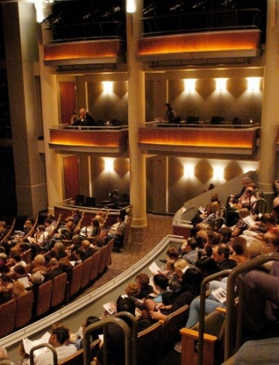Within Robinson Hall are the **Anne R. Belk Theater** and the **Black Box Theater**. The main stage space, the Anne R. Belk Theater, is a proscenium-style house which seats 340. The theater’s orchestra, mezzanine, and box seating offers patrons an environment that is both intimate and elegant. The flexible Black Box Theater space can accommodate 90 to 125 patrons for a unique theatrical experience.

The Rowe Arts building houses the 360-seat **Rowe Recital Hall** and the **White Box Theater**, a classroom and lab theatre space dedicated to the development of student works and projects.

**Productions**

The Departments of Dance, Music, and Theatre are the headliners at Robinson Hall, and the primary use of the performance spaces is to support the education of our students in the processes of performing arts production. In the weeks before a performance, the theater space becomes a laboratory as students hang lights, construct sets, work sound and rehearse, learning how to carry out the remarkable technical operations necessary to stage and produce a show.

For upcoming events, visit coaa.charlotte.edu/calendar.

**Police and  
Public Safety**

The UNC Charlotte Police Department proactively patrols and responds to calls from the University community 24 hours a day, 365 days a year. The Department is comprised of over 40 sworn police officers who have successfully completed all of the trainings and certifications required to serve as law enforcement officers in North Carolina. Patrols are conducted in marked and unmarked cars, bicycles, off-road vehicles, and on foot. Non-sworn personnel known as “Rangers” serve as extra sets of eyes and ears by patrolling and/or securing buildings and parking lots. Security personnel from the Housing and Residence Life, Atkins Library, and Halton Arena/Student Activities Center provide additional layers of safety and often work in concert with the Department.

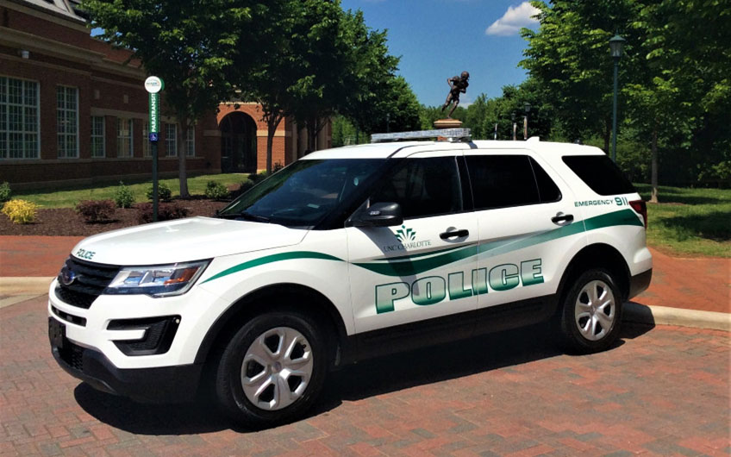

The Department’s Administrative Office is located in the Facilities Management/Police & Public Safety Building located at 9151 Cameron Boulevard across the street from the Student Health Center. This building contains the Department’s 911 Emergency Telecommunication Center which is staffed 24 hours a day that can be reached by dialing 911 from any landline on campus or 704-687-2200 from a cellular phone. Individuals in need of emergency assistance or who simply need police assistance for a non-emergency situation are strongly encouraged to call this number. Individuals who need to pick up a copy of a police report or who are searching for Lost & Found items may stop by the 1st floor lobby of this building or call the Administrative Assistant at 704-687-8300 during normal business hours.

The Department’s website contains a wide variety of information pertaining to what the Department is doing to provide for a safe and secure environment on campus and how the Department is increasing its responsiveness to the needs of the campus community. Some of the items on this website include the Department’s Annual Security Report, information on how individuals can reduce their chances of becoming the victim of a crime, and links to other community resources that assist the Department in protecting the campus community. The website also features information about the University’s nearly 300 emergency blue light phones and how individuals can sign up to receive emergency text messages. Finally, the website allows individuals to confidentially report a crime on campus or file a commendation/complaint about a particular member of the Department. For more information about any of the aforementioned items, please visit police.charlotte.edu.

**Student Engagement**

Student Engagement is committed to cultivating equity and justice while building community and developing students’ knowledge and skills through experiential learning.

**Popp Martin Student Union**

The Popp Martin Student Union serves students, faculty, staff, alumni, and visitors providing services and conveniences that members of the college community need in their daily lives and creates an environment for getting to know and understand others through formal and informal community building and programs.

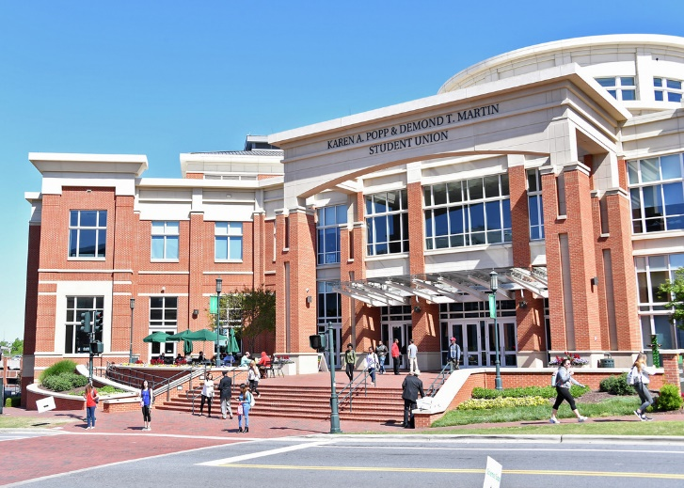

It was renamed the Karen A. Popp and Demond T. Martin Student Union in 2016 to honor the dedication and service of two extraordinary alumni, Karen Popp ('80) and Demond Martin ('97).

The Popp Martin Student Union:

* Serves as an integral part of the educational mission of the university by complementing the academic experience through an extensive array of programs, student employment, and leadership development opportunities
* Is a student-centered organization that values participatory decision-making through the Student Union Advisory Board
* Provides students with meaningful employment opportunities and substantial roles in the decision-making process that affect facilities, services, policies, and programs
* Provides meeting, gathering, office, community, event, and study space
* Supports a diversified array of programming that reflects the needs of the campus community in order to enhance educational, cultural, and developmental social interaction
* Provides a welcoming environment that is the center of campus life, due to its location, programming, and general accessibility to all members of the UNC Charlotte community
* Serves as a unifying force that honors each individual and values diversity

Visit studentunion.charlotte.edu for more information.

**NinerTech**

The NinerTech computer store is located inside the Popp Martin Student Union. NinerTech exists to support the student experience and the campus community in their computer and technology needs. Students may stop by NinerTech to purchase a computer, iPad, accessories, and more. NinerTech also features certified repair service for Apple and Dell devices. Visit ninertech.charlotte.edu for more information.

**Cone University Center**

The Bonnie E. Cone University Center was established in 1963 to provide a university center on campus to support student life. Today, it houses many student involvement opportunities, dining services, and event spaces, plus an outdoor patio. You'll find Office of Fraternity and Sorority Life, the Office of Student Assistance and Support Services (SASS), and the Peace Haven Meditation and Reflection Space. Services include Conference Services (CRES), Niner Central, and the Main Street Market dining area. The building is alive with programs and activities in event spaces including After Hours, McKnight Hall, and the Lucas Room, as well as various meeting rooms.

The Cone University Center enriches and supports the University community by:

* Contributing to the overall development of students through informal interaction, organizational participation, leadership development, and the planning for, implementation of, and participation in diverse programs
* Providing services, training, and facilities that support University programs and participation
* Providing students with meaningful employment opportunities and substantial roles in the decision-making processes that affect facilities, services, policies and programs
* Developing and administering policies and procedures that enhance campus life while ensuring an environment that is safe and secure
* Ensuring that the University community is informed of programs, resources, facilities and services

**Campus Activities Board**

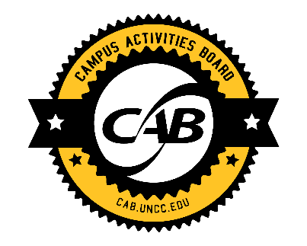The Campus Activities Board (CAB) is the largest student programming organization on campus and is responsible for planning diverse, quality events for the University community. CAB offers multiple programs a week and works to enhance and unify the University community by planning social, cultural, educational, and recreational events that complement the University’s academic mission.

CAB is located on the second floor of the Student Union. For more information, visit cab.charlotte.edu. Opportunities for student involvement include the following committees:

**CAB Live**

As the name implies, this committee is all about live entertainment ranging from comedy, live music, variety acts, poetry slams, showcases, and other entertainment trends. This committee works hard to bring a wide-variety of diverse acts to campus.

**T.A.X.I. (Talents, Activities, eXcursions and Interests)**

With this committee, anything goes! From talent shows and open mics to trips to Charlotte sporting events, this committee focuses on student talents and interests through programs and trips to explore Charlotte and other destinations.

**Daytime Niners**

This committee is all about events for Niners throughout the day (8 a.m. - 5 p.m.). Daytime events consist of interactive activities, musical performances, games, or workshops.

**Special Events**

This committee is all about one-time, large-scale events. These events are designed to draw large crowds. Special Events encompass Gold Rush (Week of Welcome) events, Homecoming events, speakers, major comedy shows, concerts, and more.

**Marketing**

This committee is in charge of getting CAB's name and events recognized on campus. From strategic branding to co-sponsorships to individual event advertising; from print to social media, Marketing and their Event Staff Street Team help make sure that UNC Charlotte students know about CAB.

**Student Niner Media Advising & Support**

Student Niner Media Advising & Support provides guidance to students in several areas of media. Student organizations housed in this department serve the campus community with forums for free exchange of ideas and dissemination of news and information. Students can gain competency in career development in a unique co-curricular setting. From writing to reporting to marketing and podcasting, Student Niner Media Advising & Support offers UNC Charlotte students a unique experience in the fast-paced world of media.

**Student Media Board**

The Student Niner Media Board is the governing body for Student Niner Media and is comprised of student representatives. Media Board is responsible for approving policies, governing documents, electing department heads, and approving the annual budget, including periodic transfers.

**Niner Times**

*Niner Times*is UNC Charlotte’s weekly student newspaper published on Tuesdays. It prints news, entertainment, sports, and more. More than 3,500 copies are distributed at more than 80 locations both on and off campus. The student-produced publication provides journalism experience to more than 80 student leaders.

**NinerTimes.com**

Ninertimes.com features breaking news and exclusive content including columns, photos, and video. UNC Charlotte news, sports, and features are posted several times each week.

**Media Marketing**

The media marketing department at Student Niner Media is responsible for advertising, circulation, and promotions. Students can work in areas including layout, design, sales, and promotions. Media Marketing offers real world experience and internship opportunities for business, marketing, and communication careers.

**Nova**

*Nova* is the nationally recognized literary-arts magazine published by students interested in the arts. Artists from around the world submit poems, short stories, visual art, and film to be included in the publication. Submissions are professionally juried, and selections are published in the annual edition of the magazine. The magazine is published in April.

**Uptown Audio**

This UNC Charlotte-based podcast network that produces a variety of shows for any listener. Listen at uapodcasts.com.

**Technical Operations**

The Technical Department is responsible for updating and maintaining Student Niner Media’s websites and social media presence. They provide equipment and software training to all departments of Student Niner Media.

**Midas Magazine**

*Midas Magazine* is Student Niner Media’s newest publication, which was started in December 2020. The cultural and entertainment magazine is published once a semester, in December and April, and offers a wide variety of content. Students can learn skills in writing, editing, graphic design, or photography when working with *Midas*.

**Internships**

Niner Media interns can earn academic credit and receive "hands on" media experience in writing, design, photography, advertising, desktop publishing, and management. Internships are offered in collaboration with the Department of Communication Studies.

For more information about how to get involved with Student Niner Media, contact the office or visit media.charlotte.edu. Offices are located in the lower level of the Popp Martin Student Union.

**Leadership and Community Engagement**

Leadership and Community Engagement provides students with opportunities to develop and strengthen leadership skills and understanding while providing the University and student organizations with more effective leadership. Programs consist of group and self-paced leadership workshops, retreats, and conferences, as well as academic courses. Individual and group consultation is also available. Opportunities for service include the Jamil Niner Food Pantry, Alternative Service Breaks, and a variety of monthly service projects in the greater Charlotte area coordinated by the SERVE team.

**Academic Certificate in Leadership Studies**

An 18-credit hour concentration in interdisciplinary leadership studies is offered, leading to the Undergraduate Certificate in Leadership Studies awarded at graduation from UNC Charlotte.

**Alternative Service Breaks**

Alternative Service Breaks (ASB) are unique volunteer experiences during which students forgo their traditional spring break activities and engage in direct service in a community outside of their own.

**Bonner Leaders**

The Bonner Leaders Program is an intensive, four-year community engagement opportunity for undergraduates who work in Charlotte-based institutions and agencies. This program is directed by the Office of Urban Research and Community Engagement.

**Emerging Leaders**

The Emerging Leaders program provides a cohort leadership experience for freshmen (applications available early Fall semester).

**Executive Leadership Program**

The Executive Leadership program, open to students with Senior standing, focuses on the transition from undergraduate leadership to leadership as a new professional.

**Individual and Group Consultation**

Assistance withapplications, interviewing, leadership issues and programmatic needs are available.

**LEAD Team**

Students in the LEAD team are trained and available to make presentations on a wide variety of leadership topics.

**LeaderShape Institute**

The Institute is a leadership program for established leaders with a focus on vision and leading with integrity.

**Leadership Fellows**

Leadership Fellows is a Fall semester cohort leadership experience for upperclassmen (applications available Spring semester).

**Leadership Journey Learning Community**

A one-year residential program is offered to first-year students who have an interest in developing or building leadership skills and abilities.

**Leadership, Communication, and Group Dynamics**

A 3-credit hour leadership theory course (COMM 3135) is taught on leadership, communication, and group dynamics.

**Leadership, Service and Ethics**

A 3-credit hour course in communication studies (COMM 3136) is offered for students interested in developing a leadership framework and obtaining academic credit.

**Noble Niner Institute**

The Noble Niner Institute focuses on one or more aspects of a Noble Niner - integrity, respect, accountability, dignity, honor, compassion, character, nobility, and scholarship.

**PILOT (Programs In Leadership and Organizational Training)**

PILOT is an individualized leadership program that provides an opportunity for leadership certification through this self-paced program.

**SERVE TEAM**

SERVE TEAM creates community service opportunities through connections with local non-profit agencies as well as campus based service and volunteer opportunities.

**Women’s Leadership Development Program**

This cohort-based women’s leadership conversation series is a Spring semester offering for students who are currently or have recently served as leaders. It provides the opportunity for interaction with and learning from women who are leaders in our community. Applications are available late Fall semester. Visit leadership.charlotte.edu for more information.

**Fraternity and Sorority Life**

Fraternity and Sorority Life at UNC Charlotte consists of over 45 fraternities and sororities founded upon the principles of scholarship, leadership, community service, and the formation of lifelong friendships through brotherhood/sisterhood. Fraternities and sororities uphold these fundamental values in their pursuit of collegiate excellence, enabling all members to achieve their personal best. Fraternity and Sorority Life provides students with an opportunity to be a part of a large group with many diverse characteristics while sharing a common goal. The fraternities and sororities work together to provide a quality experience for anyone who joins via service projects, educational programs, and social activities. The experience the student gains from organizing and motivating people, planning and implementing projects and learning to give back what one has received can be an invaluable part of a college education. Membership recruitment for a fraternity or sorority primarily begins with each new semester. However, some organizations hold recruitment meetings throughout the year. Some of the many programs within Fraternity and Sorority Life include: the Harm Reduction Symposium, Greek Weekend, Airband, Annual Stroll Competition, and New Member Convocation. Visit online at greeklife.charlotte.edu.

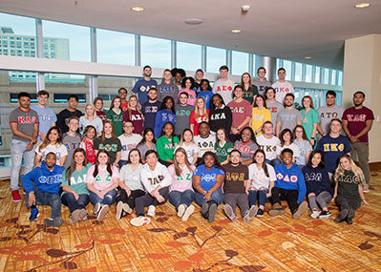

**Venture Outdoor Leadership**

Venture offers a variety of outdoor adventure and experiential learning trips, programs and workshops. Activities include trips lasting from 1-21 days in a variety of outdoor endeavors from backpacking to rock climbing to kayaking (to name only a few). Venture also hosts and facilitates many programs on its on-campus Team Challenge Course, High Team Challenge Course, and indoor climbing wall. Venture programs are modeled on the Outward Bound philosophy and are designed to facilitate individual growth through physical challenge, group interaction, and personal reflection - all while having fun. Students involved in VOLTAGE (Venture Outdoor Leadership Training and Group Experience) have the opportunity to be trained as student leaders on Venture’s trips and programs. Outdoor camping gear can be rented. Venture also operates NSO Outdoor, an opportunity for students to connect with the University and other students in meaningful ways prior to their first semester.

Venture offers courses for academic credit through the Department of Applied Physiology, Health, and Clinical Sciences. Each semester, a variety of one-, two-, and three-credit hour outdoor activity courses are offered, including courses such as: Introduction to Outdoor Adventures, Rock Climbing, Challenge Course Activities, Raft Guiding, Wilderness Experience, Wilderness Trip Leading, and Challenge Course Facilitation. Students may combine specific courses to complete a Minor in Outdoor Adventure Leadership. For additional details, see the Department of Applied Physiology, Health, and Clinical Sciences section of this *Catalog* and visit venture.charlotte.edu/academics.



For more information about Venture, please visit venture.charlotte.edu.

**Student Government Association**

The Student Government Association (SGA) advocates for the issues, needs, and interests of the student body. Many students want to make their campus a better place while they are here and find their work in student government a useful background for later public service. The leaders of student government are committed to representing the student body and to developing students' awareness of the many facets of campus life, working with the University’s administration in advancing the needs and interests of students. All enrolled students, both full- and part-time, are eligible to participate in student government. Visit online at sga.charlotte.edu.

The Student Government Association is comprised of:

**Executive Branch**

The Executive Branch is comprised of the Student Body President, Student Body Vice President, Chief of Staff, four class presidents, and Executive Cabinet members, who are appointed by the President. The Student Body President serves as a member of the UNC Charlotte Board of Trustees.

**Legislative Branch**

The Legislative Branch is the Student Senate, which is comprised of the Speaker of the Senate and representatives from each academic college who are elected by the students with majors in the college, as well as at-large representatives for certain constituencies.

**Judicial Branch**

The Judicial Branch is composed of student panel members led by the Chief Justice. The branch includes the Chief Justice, Lt. Chief Justice, and 5 other student justices. They are responsible for investigating and reviewing violations of the Student Body Constitution, and the Student Government Bylaws, and reviewing constitutionality of Legislative Branch and Executive Branch actions.

**Student Involvement**

Student Involvement supports students’ engagement with campus through organizations and special events. UNC Charlotte has over 400 student organizations that enhance the academic experience of UNC Charlotte students and provide opportunities to get involved. The categories of student organizations include: academic (pre-professional), fraternities and sororities, graduate organizations, honor societies, interest, performance, service, political, religious, multicultural, international, sport clubs, and media/publication. There are many benefits to joining a student organization, including making new friends, developing new skills and abilities, working collaboratively as part of a team, learning to set and achieve goals, leadership opportunities, as well as having fun. Students may also start a new student organization if there is not one already on campus that matches their interests. Contact Student Involvement with questions about resources available and how to get connected. Contact information and a current listing of all registered student organizations is available online at studentorgs.charlotte.edu.

Student Involvement also hosts special events such as Homecoming, Haunted Union, and Late Night Breakfast that build spirit and tradition for the Niner Nation.

**Sustainability**

**sustainability.charlotte.edu**

The Office of Sustainability works with faculty, staff and students to measure progress, propose solutions, initiate changes, develop skills, and share experiences that contribute to environmental, social and financial dimensions of sustainability.

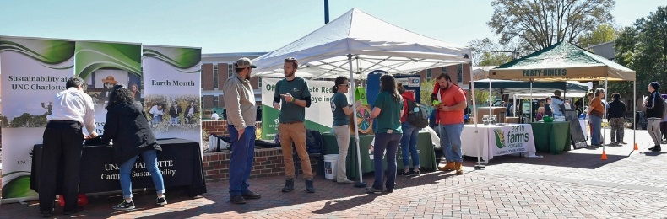

The Office of Sustainability works to:

* Lead initiatives in zero waste, responsible purchasing, and

achieving carbon-neutral campus by 2050

* Partner on events to raise awareness of campus and community

issues, programs and solutions, including Campus Sustainability Week in Fall and Earth Month in Spring

* Support students, student organizations, and departments that

propose projects to the Charlotte Green Initiative at cgi.charlotte.edu

* Help faculty address sustainability topics in courses, through

workshops, presentations, tours and initiatives to use campus as a learning lab

* Coordinate research on campus operations that lead to lower

environmental impacts, improved social outcomes, and reduced costs

* Hire students to engage the campus community through

communication and events, to measure and report our progress on sustainability goals, and to study social and technical innovations

* Organize volunteers to address litter, uphold our Zero Waste

Stadium pledge, plant trees, and maintain student and staff gardens

To learn more about the history, priorities, progress, resources, and opportunities on campus, visit sustainability.charlotte.edu.

**Technology**

**OneIT.charlotte.edu**

The Office of OneIT provides the University with IT services and manages campus technologies that support teaching, learning, research, and business processes.

Services include:

* Providing IT help at your fingertips: Visit help.charlotte.edu or call 704-687-5500
* Connecting Niners to University software and beyond at software.charlotte.edu
* Administering secure “eduroam” Wi-Fi for all educational buildings and common campus areas
* Maintaining the University’s extensive FAQ library at faq.charlotte.edu
* Suggesting hardware recommendations for the University laptop requirement at oneit.charlotte.edu/laptop
* Managing University computers, operating systems, software, voice and data networks and centralized servers
* Overseeing core administrative systems such as Gmail, Banner, Canvas, and My UNC Charlotte
* Supporting the University’s web presence

For a complete list of available IT resources, current IT news, or more about the Office of OneIT, visit oneit.charlotte.edu.

**University Advancement**

**advancement.charlotte.edu**

The Division of University Advancement at UNC Charlotte manages the campus’ external environment by leading the University’s communications’ strategies and by building strong, progressive relationships between the University and its alumni, students, faculty and staff, donors, friends, corporate partners and elected officials to help advance UNC Charlotte’s strategic initiatives.

The departments within University Advancement include Advancement Operations, Alumni Affairs, Community Relations, Constituent Relations, University Communications, University Development, and University Events.

**Advancement Operations**

University Advancement Operations provides infrastructure, information, and services to support the University’s fundraising and engagement activities; to ensure the responsible and ethical management of our alumni and donor database and gift systems; to execute purposeful programs and services to alumni, students, parents, and friends; and to maintain all administrative functions of the Division of University Advancement.

**Alumni Affairs**

Alumni Affairs develops, coordinates and promotes programs and events for UNC Charlotte alumni, 150,000 strong; including alumni groups and regional networks, award programs, Homecoming and AlumNiner Weekend. Alumni Affairs staff also manages two event venues on campus – the Harris Alumni Center at Johnson Glen and the Hauser Alumni Pavilion, the site of pre-game alumni tailgates.

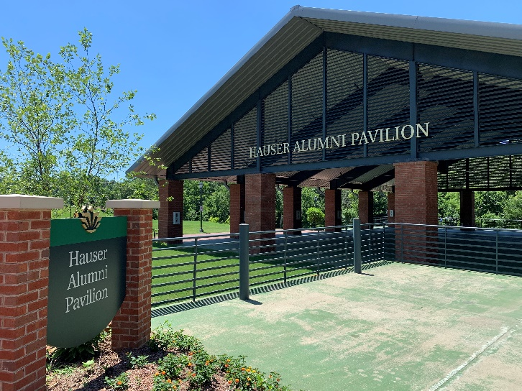

The UNC Charlotte Alumni Association works to promote a close relationship between alumni and the University by fostering a spirit of loyalty and fraternity among UNC Charlotte graduates, former students, and friends, and by encouraging alumni to become personally involved in and financially support University activities. The Board of Directors of the Alumni Association is comprised of alumni who represent the general body of alumni and at least one of each of the seven academic colleges of the University and the graduate school, so much as possible.

**Community Relations**

Community Relations works to strengthen the connection between UNC Charlotte and the greater Charlotte community through intentional and meaningful partnerships with key cultural, educational, social and civic organizations. This is accomplished through targeted outreach initiatives and projects that encourage faculty and staff to use their time and talents in support of the greater Charlotte community. The Community Relations team also coordinates the Community Engagement Orientation for new faculty and senior staff, as well as various community panels.

**Constituent Relations**

Constituent Relations fosters, supports, and advances UNC Charlotte’s relationships with state, regional, and local government officials and agencies, as well as with the business and corporate community, strengthening the University in its mission to deliver on its promise as the region’s premier urban research university. From welcoming government representatives to campus to providing information and access, Constituent Relations forges the link between UNC Charlotte and our public representatives.

Additionally, the unit is responsible for enhancing and promoting a strong, effective relationship with the UNC Board of Governors, as well as with business advocates including the Charlotte Regional Business Alliance. Constituent Relations has co-led transformational, interdisciplinary efforts, including the implementation of light rail onto campus, and engagement with the 2012 and 2020 presidential nominating conventions, ensuring unique, informative opportunities for our students, faculty, staff, and community.

**University Communications**

The mission of University Communications is to elevate the brand reputation of the University by shaping the UNC Charlotte story through strategic communications to internal and external stakeholders. The University Communications team is composed of media relations and reputation management, creative services, internal and operational communications, editorial services, marketing, broadcast and digital media, social media, and web/email communications. The team works with a network of college communicators in the divisions and colleges to provide strategic communications support and guidance to further the Institution’s mission.

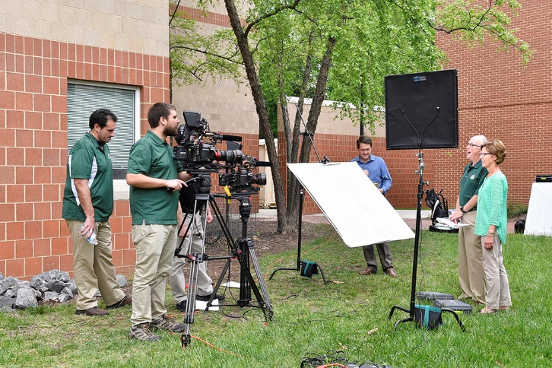

**University Development**

The Office of University Development -- composed of major gifts, leadership gifts, annual giving, and planned giving -- builds philanthropic relationships that engage UNC Charlotte alumni, donors, students, faculty, staff, and friends in supporting the University's mission. Thanks to the generosity of UNC Charlotte’s donors, University Development campaigns, including #NinerNationGives and the largest in University history - Exponential: The Campaign for UNC Charlotte, truly transform the University by providing scholarships and resources to our students, research opportunities to our faculty, and reaffirming our position as an economic engine for the Charlotte region.

**The Foundation of the University of North Carolina at Charlotte, Inc.**

Founded in 1960, the UNC Charlotte Foundation is a 501(c)(3) non-profit organization whose purpose is to support the educational mission of UNC Charlotte. Its work centers on engaging the community, soliciting private donations, establishing scholarships, and managing property and other assets to benefit the students, faculty, and staff of UNC Charlotte. An elected Board of Directors, composed of no more than 45 volunteers, governs the Foundation.

University employees perform the fund-raising and business functions of the Foundation. In exchange, the Foundation transfers funds to UNC Charlotte to enhance the institution’s teaching, research, and service missions. The Foundation endowment is approximately $131 million, and the total University endowment is more than $210.2 million.

**University Events**

University Events initiates, plans, and implements strategic events and programs that build relationships and strengthen ties to UNC Charlotte. University Events plans and executes all events hosted by the Chancellor including receptions at the Chancellor’s residence (Bissell House), groundbreakings and dedication ceremonies, donor events, award ceremonies, and lectures.

University Events oversee the UNC Charlotte Civic Series presented by Bank of America. The series brings nationally recognized speakers to UNC Charlotte and the greater Charlotte community for thought-provoking conversations throughout the year. Featured in the series are three annual events: The Chancellor’s Speaker Series, the Barnhardt Seminar on Ethics and the World of Business and the TIAA Lecture Series.

University Events is also responsible for the planning and execution of the University’s annual commencement ceremonies. The office oversees every aspect of planning surrounding commencement, from the tickets to the logistics and execution of each ceremony.